Morgan Fratto

De Jung

ENC 2135-118

20 January 2016

Musically Made

“I’m going home, to a place where I belong, and where your love has always been enough for me.”

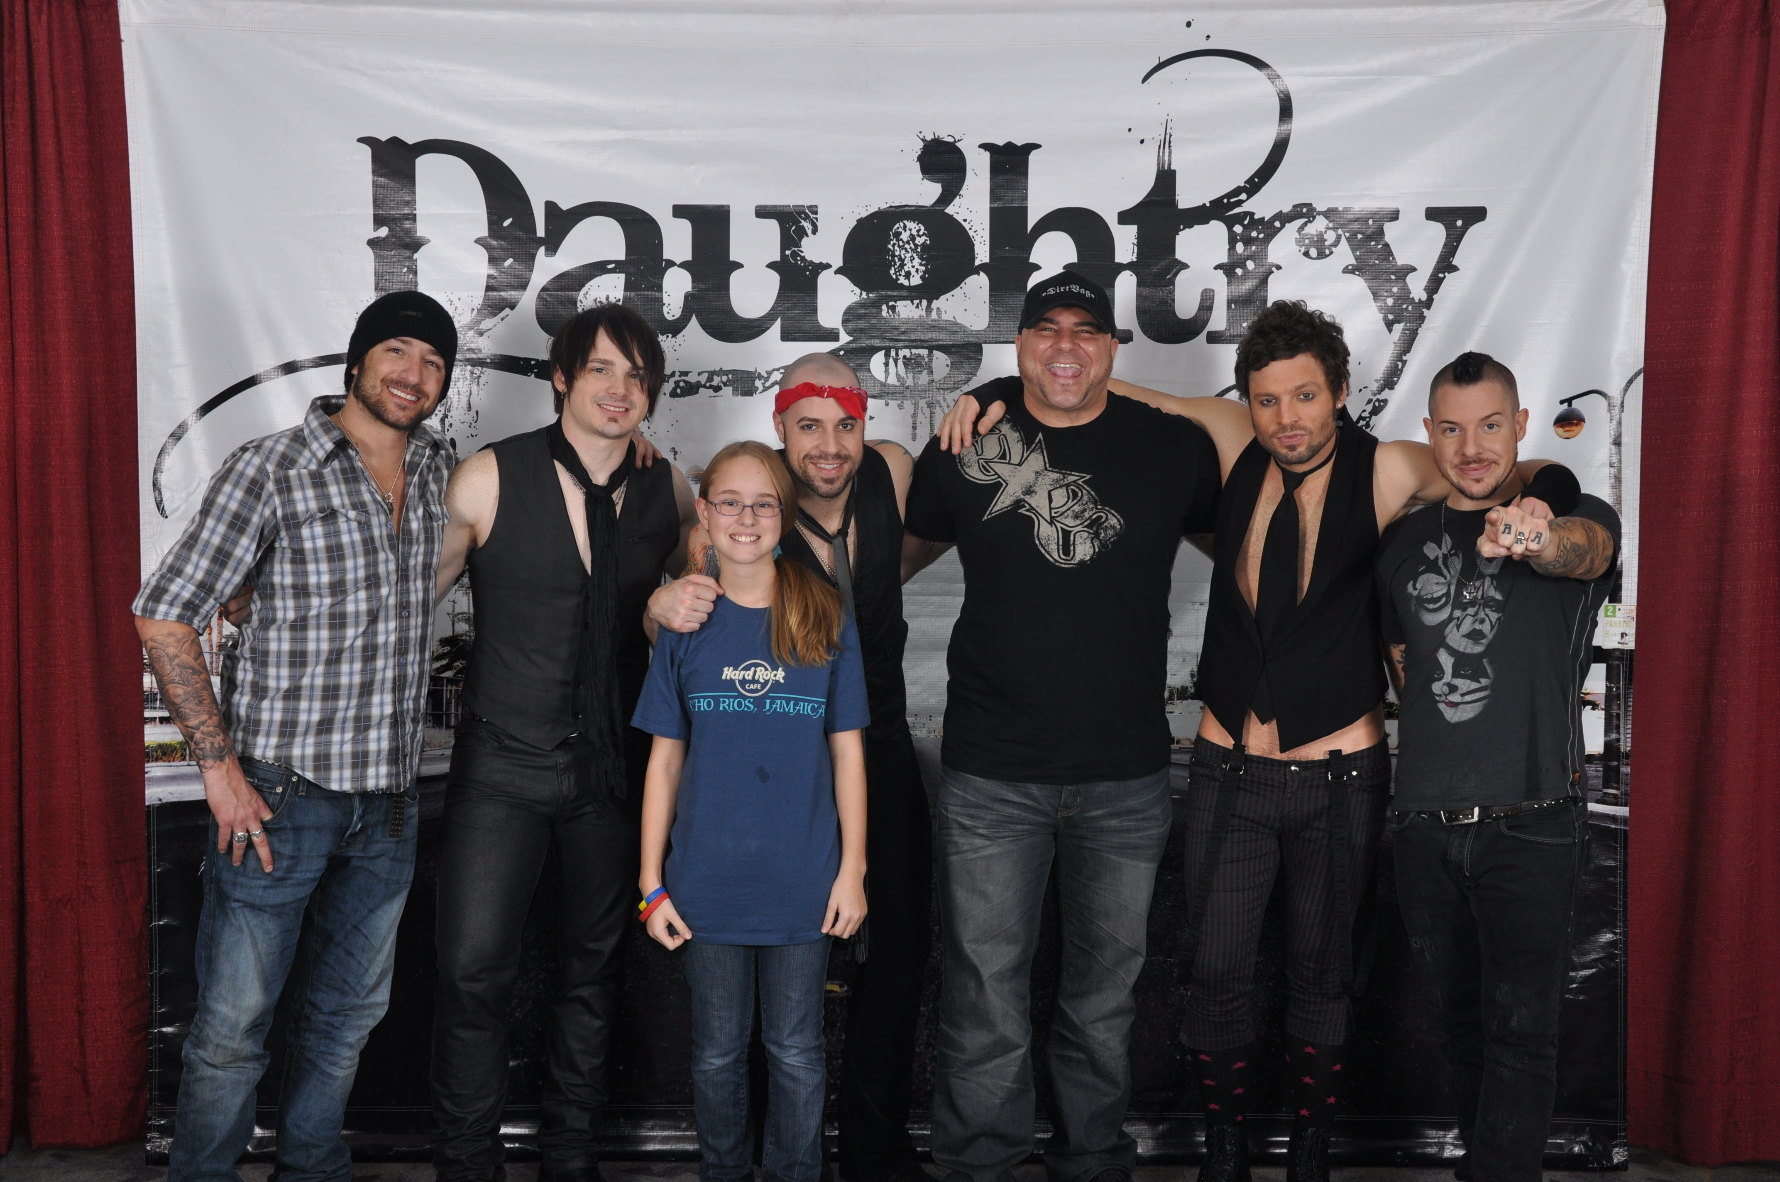 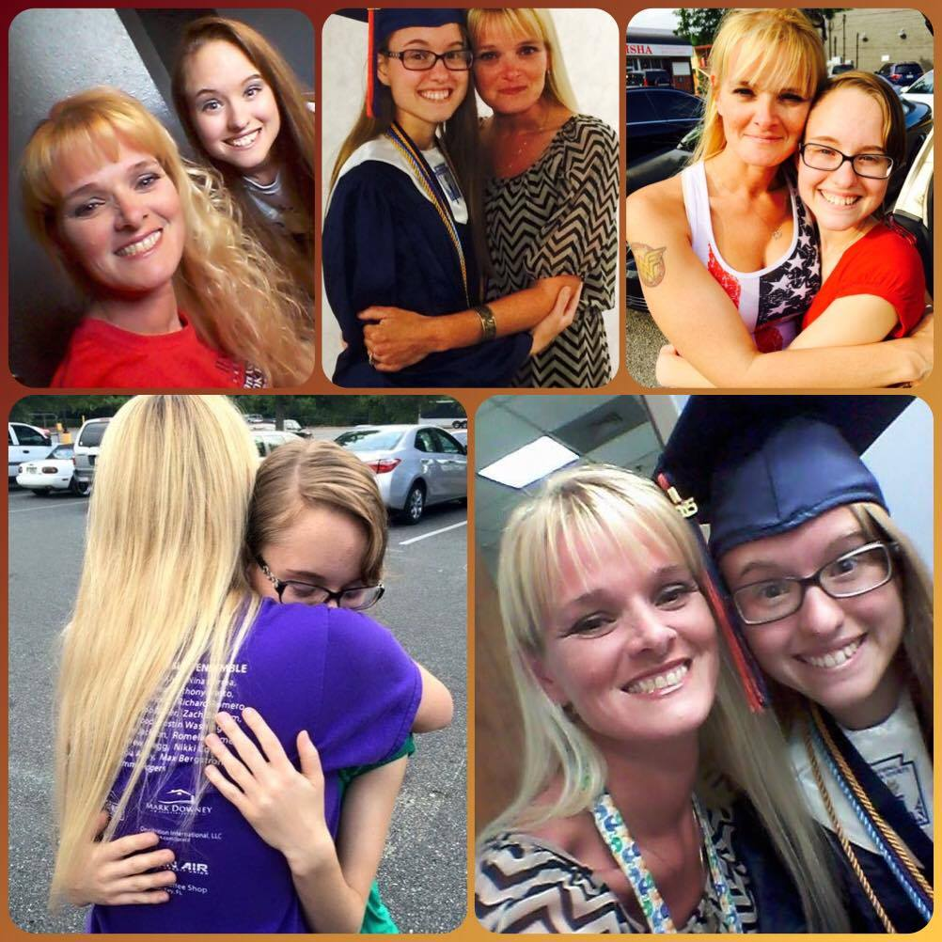

In 2008 and again in 2012, I went to my local civic center to watch Daughtry perform. Afterwards, I even met the band and got autographs on posters and CD’s I had. I love almost all of their songs, still to today, but “Home” was the first one that my mom and I bonded over. When we moved from Pensacola, Florida to Pittsburgh, Pennsylvania, my mom and I would listen to all of our favorite songs in the car, but the one we just kept coming back to each time was “Home”.

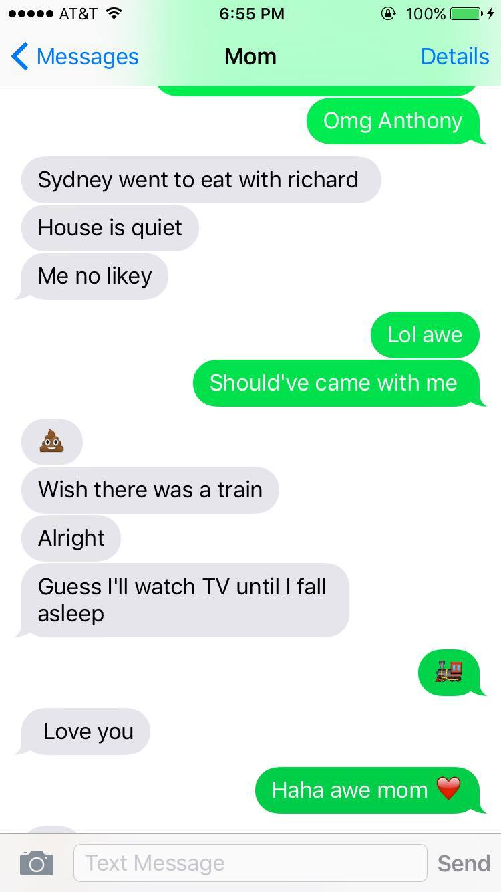I built such a strong connection with my mom over this particular song, and even now when I come home from college to visit, I play this song and it makes me think that I am almost there, that I am that much closer to seeing my mom and being able to hug her again. We text all the time because we both dread being stuck in a phone call when there is only a couple things that need to be said. Even with the text messages, the Facebook posts, and the occasional phone call, it just never seems like enough to subside the want of a good hug from her. My mom has stuck by me through so much and helped me to become the woman I am today, a “mini-me” as she likes to call me. This song reminds me that home is not simply just a place, but a feeling that comes from being surrounded by the people that love you the most in the world.

“I don’t want to close my eyes, I don’t want to fall asleep ‘cause I’d miss you baby and I don’t want to miss a thing.”

Walking into this beautifully lit room with somewhere around forty people dancing on the dance floor in front of the DJ’s set up and I hear this song start to play. I turned to my right to the person holding onto my hand, my bestfriend, Blake, who is looking at me with the kindest of eyes like I am the most beautiful girl in the world, and even more so at this prom. This song, out of all the slow songs the DJ could have picked from, is what is playing on the speakers around 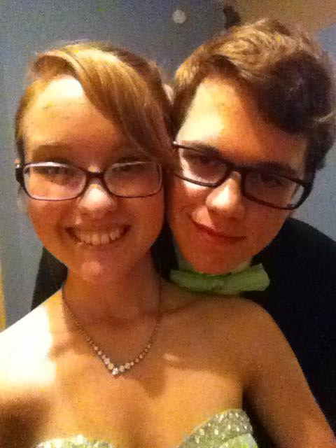the room. I walked to the left of the dance floor and I turn around to face my date as he pulls me toward him so we could dance. In that moment is when this song became “our song”.

Since that moment almost two years ago, I am flushed with every wonderful memory that I have stored in my mind of my bestfriend every single time I hear this Aerosmith song, “I Don’t Want to Miss a Thing”. This song helps me to remember all of those good times I shared with my bestfriend, Blake, when I am ever feeling alone. I always wanted to just stop every time Blake and I would go on dates or simply hang out because I wanted to save the moment in my memory so I could go back, cherish it, and remind myself that love is real and that he was my example of that.

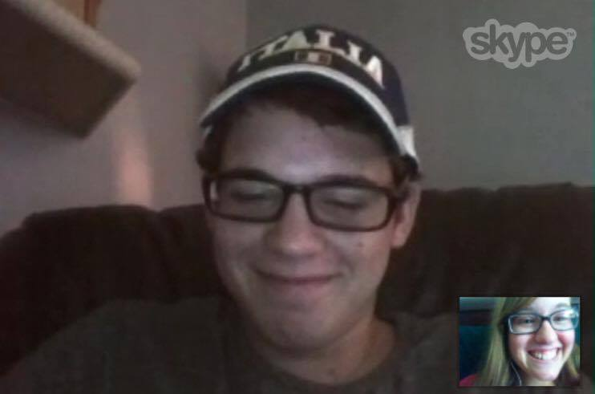Blake and I text, call, Snapchat, and Skype all the time; I love talking to him and hearing about how his day is and how he’s doing. This man has changed my life in the most wonderful ways; he has opened my eyes to love, kindness, and friendship. While showing me that it is okay to stop and cherish the good times, my bestfriend has also shown me that you need to pay attend to what life is throwing at you because you will not want to miss it. The lyrics in this song remind me that “I don’t want to miss a thing”, which pertains to life in general because it seems like so many life-altering events are happening that you do not want to miss. Miracles, the losses of loved ones, and even true love (if you are like me and believe in that sort of thing) can happen in the blink of an eye.

“No, I don’t want no scrub. A scrub is a guy that can’t get no love from me. Hangin’ out the passenger’s side of his bestfriend’s ride, trying to holla at me.”

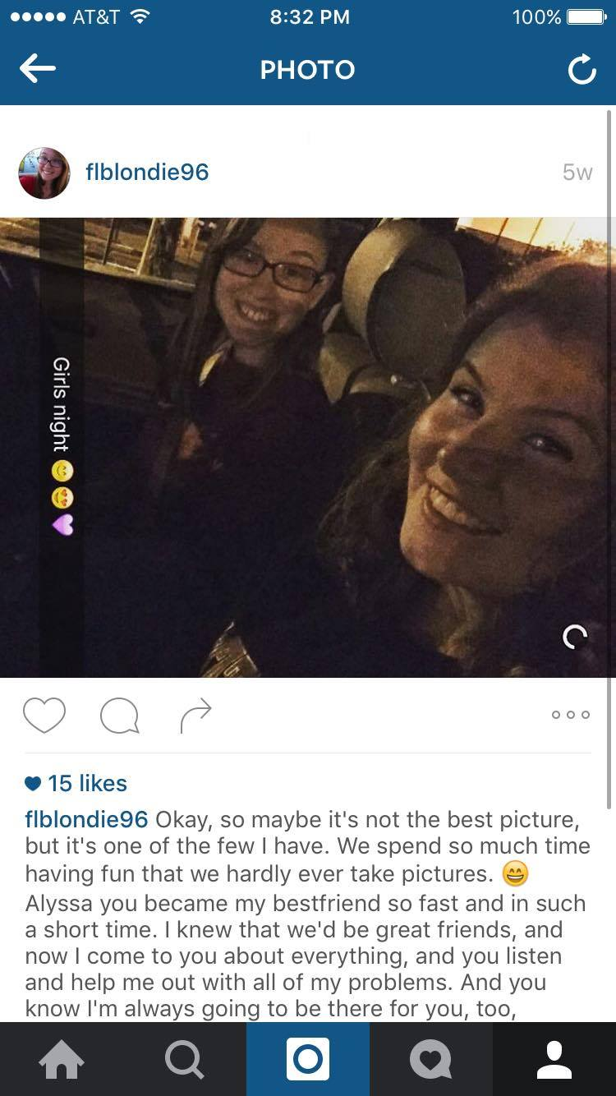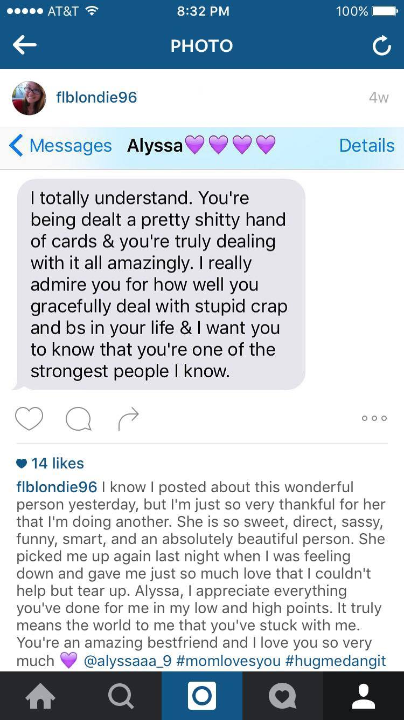“No Scrub” by TLC was an iconic song back when it came out, and even more so for me now that it has helped turn a friend into a bestfriend. I met Alyssa in high school during our senior year, but once I found out we were both going to be attending Florida State University in the summer of 2015, I knew that we had to room together. As soon as we moved into our dorm room on FSU’s campus, Alyssa and I started talking and quickly became friends. One day, I offered to drive us to get frozen yogurt and I put on this song. After about the first verse, I felt as though our friendship had changed. Ever since that car ride filled with loud singing, wild dance moves, and talking for hours afterward, Alyssa and I have been bestfriends. We talk every day through texting and Snapchat if we do not get to see each other for class or lunch. Alyssa has helped me through some rough areas in my life and has talked me through all of the problems I have encountered, just as I do for her. This wonderful person has made me into a more outgoing person who is not afraid of her feelings as much as before. Alyssa truly is my bestfriend and I try to tell her how much I appreciate her every chance I get.